iPhone Camera App: The Ultimate Guide To Incredible iPhone Photos
Posted by Emil Pakarklis | January 8, 2019Comments 144
1. Quickly Open The iPhone Camera App
There are several quick ways to open the iPhone’s built-in Camera app.
If your iPhone is locked, simply tap the screen to wake up your phone (or press the Home button on older iPhones). Then swipe left.
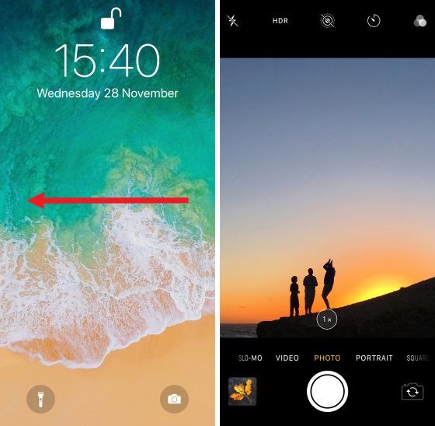
The Camera app will slide onto the screen and you can start shooting immediately. If you’re already using your iPhone when you want to take a photo, use one of the following techniques to open the Camera app.
If the Home screen is visible, tap the Camera app icon.
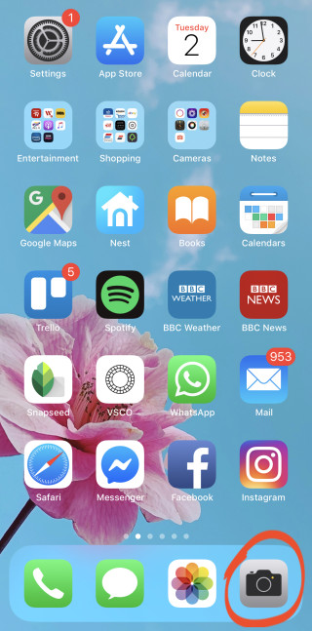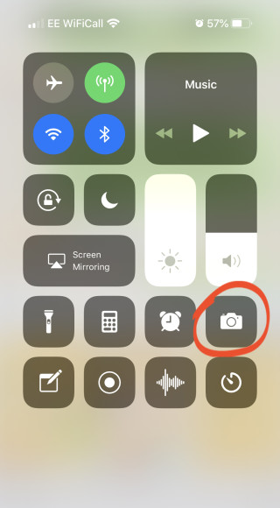
It’s best to add the Camera icon to the dock area at the bottom of the screen. This makes it easier to find and open quickly.
To add the Camera icon to the dock, tap and hold the icon until it starts to jiggle. Drag the icon to the dock at the bottom of the screen. Then tap Done at the top right.
Note that you can only have four icons in the dock. So if the dock is already full, you’ll need to drag one of the other icons out of the dock first.
What if you’re using a different app and want to quickly open the Camera? There’s no need to close the app.
Simply swipe down from the top right of the screen (on older iPhones swipe up from the bottom edge). This opens the Control Center where you can tap the Camera icon.
If you want to start taking great pictures with your iPhone, you have to be ready to shoot quickly.
These iPhone camera tricks ensure you’ll be able to start shooting in a second or two. So you’ll never miss a great photo opportunity again!
Now you’ll learn how to use iPhone camera settings to create the most stunning images.

2. Turn On The Camera Grid For Improved Composition
The built-in Camera app lets you display gridlines on the screen. The grid has two horizontal and two vertical lines as shown below.
These gridlines help you create photos with better composition. For example, you can use it to compose your shot according to the rule of thirds.
This rule states that it’s better to place your subject off-center, rather than in the middle of the frame. Use the grid to position your subject where two of the gridlines meet.
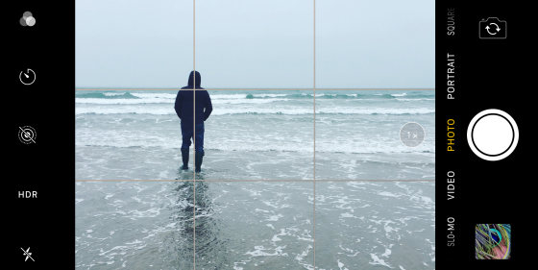
When shooting landscape photos, position the horizon along the top or bottom gridline, rather than across the middle.
The grid is also an amazing tool for keeping your iPhone straight when taking photos. Use the gridlines to ensure the horizon is level before you press the shutter.
To switch on the gridlines, open the Settings app and select Camera. Ensure the Grid option is on (green).
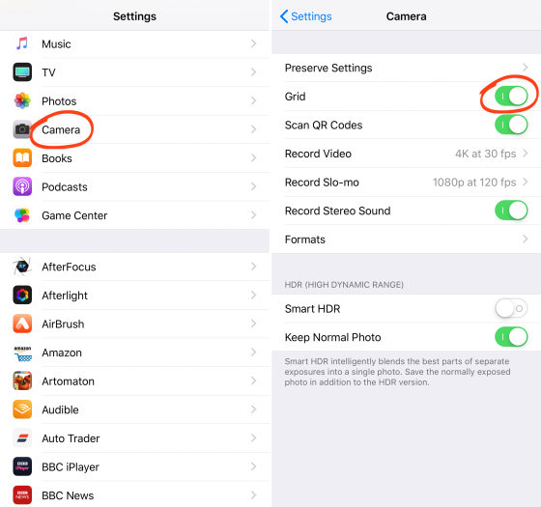
Close Settings, and open the Camera app again. The gridlines will be visible in the viewfinder.
Enabling the grid feature also activates the leveling tool. This tool helps you take level photos when shooting straight up or down.
When you point your iPhone up or down, you’ll see a pair of white and yellow crosshairs in the middle of the screen. When your iPhone is parallel with the ground or ceiling, the crosshairs merge into a single yellow cross.
3. Choose The Right Shooting Mode
Swipe left or right to scroll through the different iPhone camera modes at the bottom of the screen. Photo, Square, Portrait, Pano, Video, Time Lapse, and Slo-Mo
.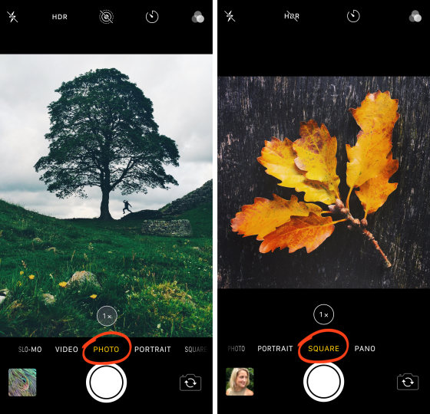
Photo mode captures rectangular photos, while Square mode shoots square photos.
Pano mode lets you capture super-wide panoramic shots. This is great for wide landscapes and cityscapes. Hold your iPhone in vertical orientation, then tap the shutter button. Move your phone across the scene in the direction of the arrow to capture your panorama.
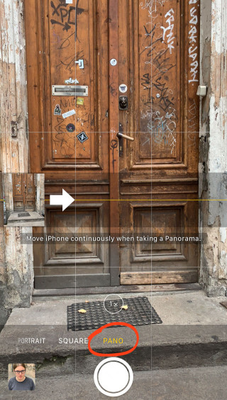
Video mode allows you to record videos on your iPhone.
Slo-Mo mode captures slow-motion video.
Time-Lapse mode creates sped-up video footage.
5. Set The Focus For Pin-Sharp Images
Important iPhone camera tricks you can learn is how to set focus in your photos.
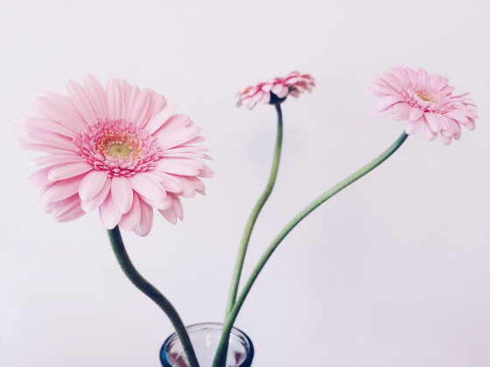
If you don’t set the focus point yourself, your iPhone will choose which area of the scene to focus on.
It may focus on your intended subject, but it won’t always get it right. So it’s best to set the focus yourself. That way, you can be sure that your subject will always be pin-sharp.
Setting the focus point is very easy in the iPhone Camera app. Frame your shot, then tap the spot that you want in sharp focus. This would usually be your main subject. A yellow square appears to indicate the focus point
.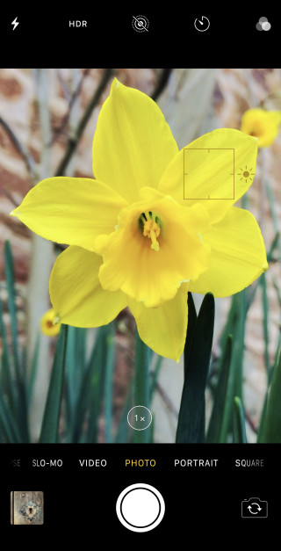
Setting the focus point is especially important when shooting close-up photos. When the lens is close to the subject, you’ll get a shallow depth of field. This means only a small area of the scene will be in focus, while the rest appears blurred.
As you can see, learning how to take good photos with iPhone involves always getting the focus perfect. This is an easy way to start taking better photos today!

6. Adjust Exposure For Perfect Brightness Levels
Exposure refers to the brightness of a photo.An under-exposed photo looks too dark, while an over-exposed photo looks too bright. A well-exposed photo will have great color and detail.
When you tap to set focus, the camera automatically sets the exposure (brightness) of the photo. It sets the exposure level based on the area you tap.
If you tap a bright area of the scene, the bright parts will be correctly exposed with plenty of color and detail. So in a landscape scene, you can avoid the sky being over-exposed by tapping an area of bright sky.
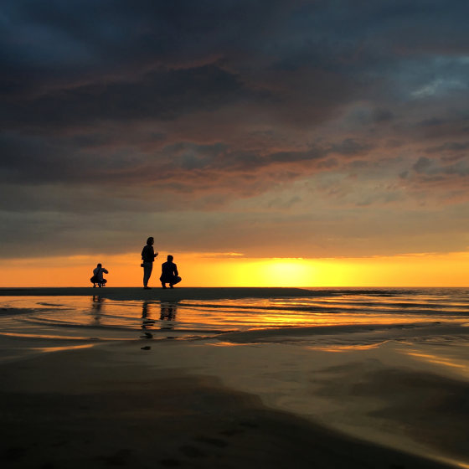
But keep in mind that the darker areas of the scene may appear under-exposed (which can actually look good if you want your subject to appear as a silhouette).
If you tap a dark area, the camera exposes for the dark parts of the scene. In other words, you’ll see color and detail in the dark areas of the image. However, the brighter areas, such as the sky, may appear over-exposed (as shown below).

Look at the examples below. Tapping to set focus on different parts of the scene has a big effect on exposure.
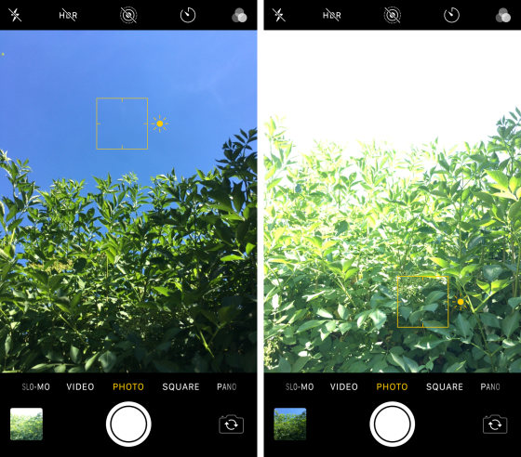
But you might not want the focus and exposure points to be the same. For example, you might want to focus on a subject in the foreground while exposing for the sky.
That’s not a problem! The iPhone provides an easy way to adjust exposure after setting the focus point.
After tapping to set focus, simply swipe up or down to adjust the exposure (brightness). Swipe up to make the image brighter or down to make it darker.
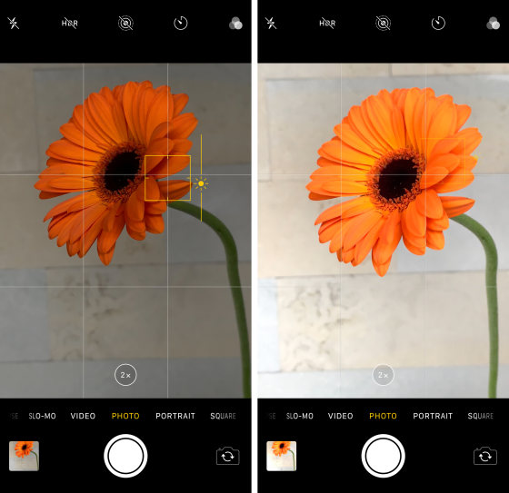

7. Lock Focus & Exposure With AE/AF Lock
The built-in Camera app lets you lock focus and exposure when taking photos. This locks in the current focus and exposure settings until you choose to unlock them.
To lock focus and exposure, tap and hold the screen for a couple of seconds. A yellow box with AE/AF LOCK will appear at the top of the screen.
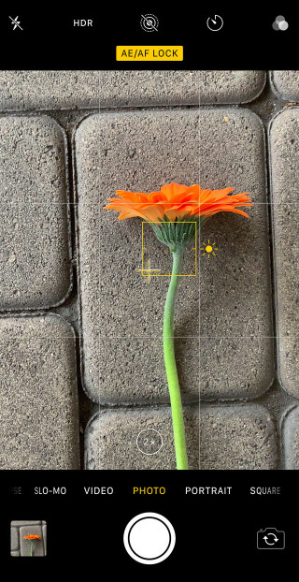
Note that you can still swipe up or down on the screen to adjust exposure manually
take several photos of a scene without having to set focus and exposure for each shot. Set it once, then keep shooting as many pictures as you want.
.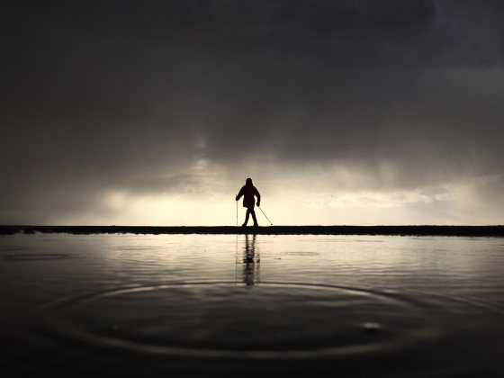
Another situation where you would use AE/AF Lock is if anything is moving in the scene. If you don’t lock focus and exposure, the camera might re-focus on anything that moves within the frame.
AE/AF Lock is particularly useful in street photography. You can compose the photo in advance, locking focus on the area where you think a person will appear. Then wait for a person to pass through the frame and press the shutter.
Because you used AE/AF Lock, the camera won’t re-focus or reset exposure when a moving subject enters the scene.
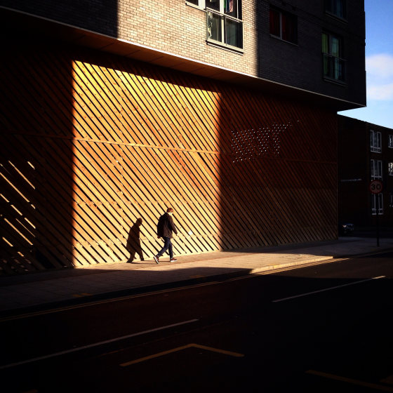
AE/AF Lock is one of the most under-used iPhone camera settings. But it’s also one of the most useful iPhone camera tricks you can learn!
8. Use HDR To Capture More Detail In High Contrast Scenes
What’s the secret to taking perfectly-exposed photos of high contrast scenes?
It’s called HDR
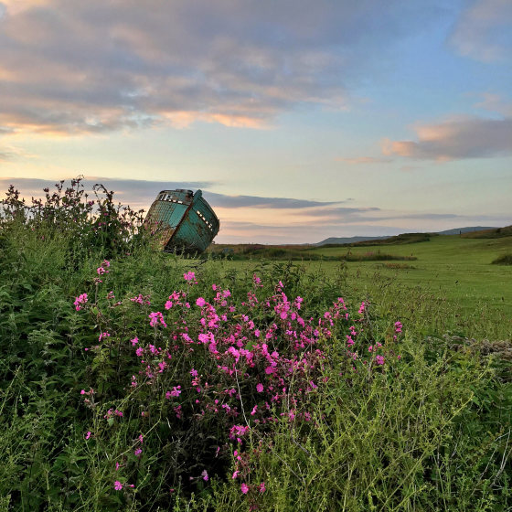
HDR stands for High Dynamic Range. Normally, your camera will struggle to capture all of the detail in a high contrast scene.
It either captures detail in the highlights (bright areas), but the shadows (dark areas) appear too dark. Or it captures detail in the shadows, but the highlights appear too bright.In the photo below, notice how the bright areas of sky are completely white with no detail at all
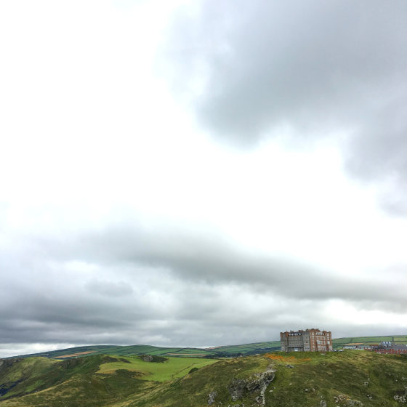
HDR allows you to create a well-lit photo with plenty of color and detail in both the shadows and the highlights.
It works by capturing several photos of the scene: normally-exposed photos, bright photos, and dark photos. These images are then automatically blended to create a single, perfectly-exposed photo.
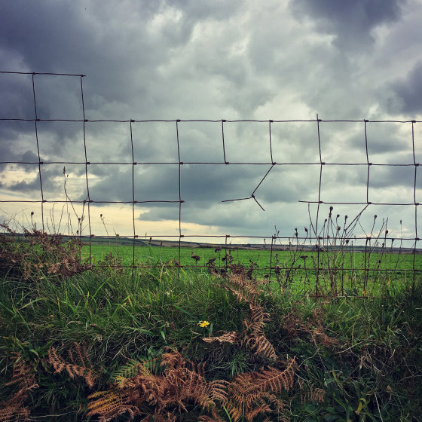
HDR is ideal for landscape photography where you have a bright sky and a darker foreground. Switching on HDR will result in stunning images that are rich in color and detail.
Open the Settings app to check your HDR settings. Go to Settings > Camera.
Ensure the Smart HDR feature (Auto HDR on older iPhones) is switched off. If this feature is switched on, you won’t see the HDR option in the Camera app.
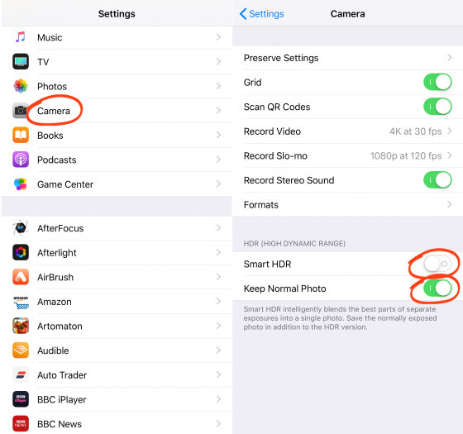
Also, make sure the Keep Normal Photo option is switched on. This ensures your camera always saves a non-HDR version in addition to the HDR photo. So if you don’t like the HDR effect, you can always use the normal image.
Close the Settings app, then open the Camera app.
Tap the HDR icon at the top of the screen. The HDR icon appears with a line through it when it’s switched off. So ensure the icon appears without the line as shown below.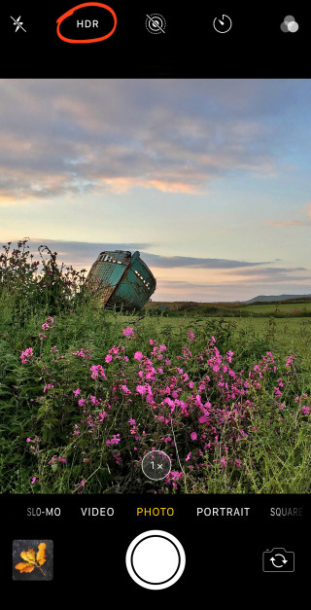

Now, just go ahead and take some pictures of a high contrast scene. The camera will work its magic and capture wonderful HDR photos with great exposure.

9. Use Burst Mode For Amazing Action Shots
Burst mode is one of those hidden iPhone camera features that you might not even realize is there. But once you discover it, you’ll see a huge improvement when photographing moving subjects.
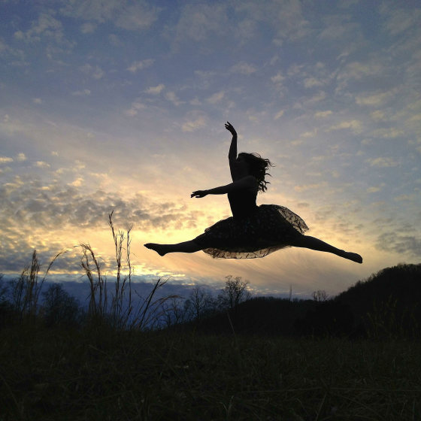
Burst mode takes ten photos per second for as long as you hold down the shutter button. This makes it easy to capture the perfect action shot with minimal blur.
To activate burst mode, hold down the shutter button for half a second or longer. Your iPhone will start taking photos in quick succession.
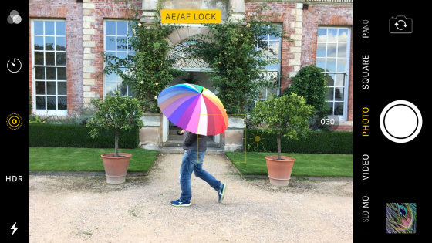
After shooting a burst of images, you can choose the best photos from the sequence and delete the rest.
To select the best images, open the Photos app and find your burst. Tap to open the photo, then tap Select at the bottom of the screen. Scroll through the burst photos and select the ones you want to keep. Then tap Done.
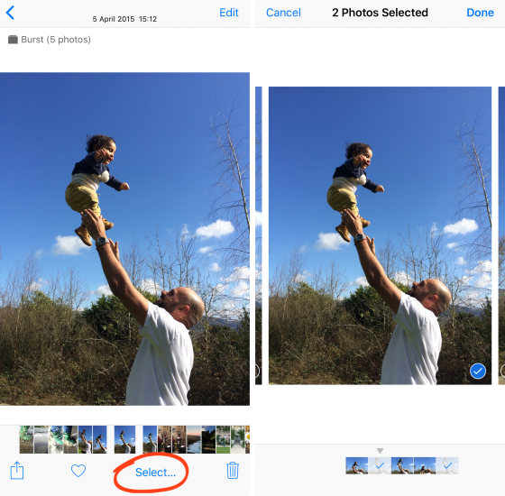
Use burst mode whenever there’s movement or unpredictability in the scene. It’s perfect for photographing children, animals, birds, and water splashes.
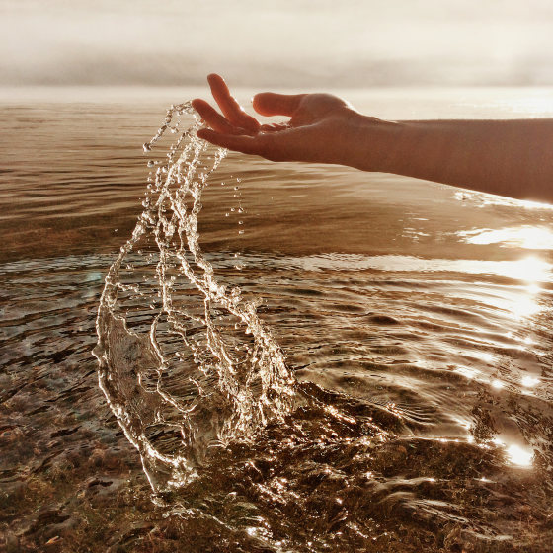
It’s also great for capturing magical moments in street photography. Try using burst mode to capture the perfect stride or pose
.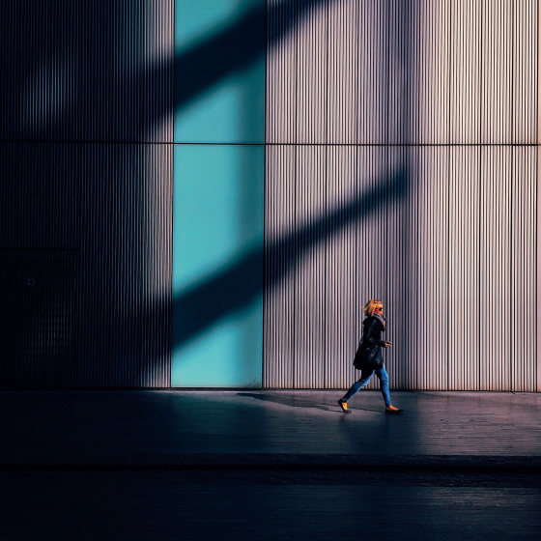
10. Shoot Live Photos To Bring Your Images To Life
Live Photos is an exciting iPhone camera feature that brings your photos to life. Rather than freezing a moment in time with a still photo, a Live Photo creates a wonderful moving image.
It works by capturing the moments before and after you take the picture. The result is a 3-second video, complete with movement and sound.
Below is a Live Photo shot at the beach. Hit the Play button to see how it captured the movement of the water and people.
Note that Live Photos is only available on the iPhone 6s/6s Plus and newer.
Switch on Live Photos by tapping the circles icon at the top of the Camera app.
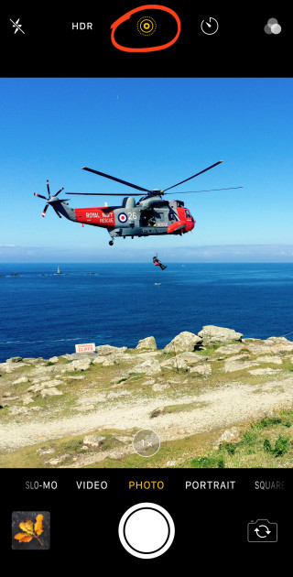
When the icon is yellow, Live Photos is on. When you press the shutter button, the camera saves video footage of the 1.5 seconds before and 1.5 seconds after that moment.
After shooting a Live Photo, play it back by pressing down firmly on the screen. You need to press harder than you’d press for an ordinary screen-tap.
When you’ve captured a Live Photo, you can apply a Loop, Bounce or Long Exposure effect if you wish. To access these effects, open your Live Photo then swipe up.
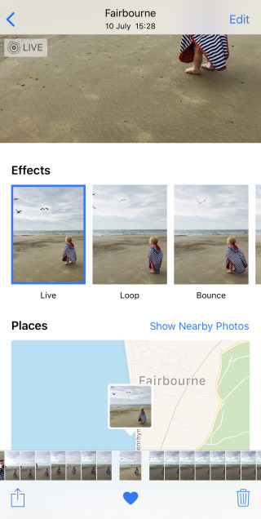
Loop turns your Live Photo into a continuous video loop. Bounce makes your Live Photo play forwards and then in reverse.
Long Exposure creates a beautiful slow shutter effect, blurring any movement captured. This is perfect for creating a silky smooth effect on waterfalls and rivers.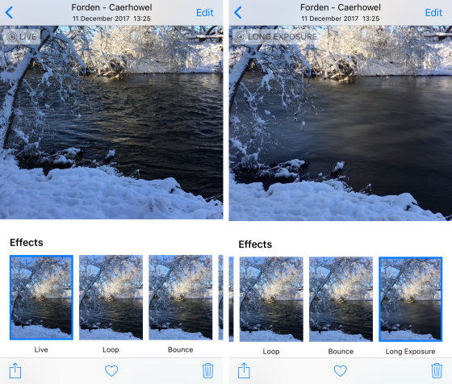

What if you want to share a Live Photo?
Most methods of sending a Live Photo result in a still image. But there is an easy way of sharing a Live Photo: save it as a video, first! For more on this, read our guide: How to save a Live Photo as video.
Use Live Photos whenever there’s movement or sound in the scene that you’d like to capture. It works particularly well when photographing people – especially children. And it’s great for capturing scenes with flowing water.
Live Photos is also perfect for situations where the sound adds an extra sensory element. For example, you could capture birdsong or the sound of water when you’re shooting in nature. Or why not capture the sounds of a bustling city scene?
You’re unlikely to use Live Photos for all your shots. But it’s perfect for preserving those moments that you couldn’t capture in a still photo.

